**Assignment 1**

Chinmay Dorge

LCS2020022

Q1) Write a Java code for designing a simple calculator with five arithmetic operators (addition, subtraction, multiplication, division, and modulo) and three logical operators (and, or, and not).

Code: Q1.java

import java.util.Scanner;  
public class Q1{  
 public static void main(String arg[]){  
 Scanner sc = new Scanner(System.in);  
 System.out.println("Enter the number next to the operation: ");  
 System.out.println("1. Addition");  
 System.out.println("2. Subtraction");  
 System.out.println("3. Multiplication");  
 System.out.println("4. Division");  
 System.out.println("5. AND");  
 System.out.println("6. OR");  
 System.out.println("7. NOT");  
 int input = sc.nextInt();  
 if(input == 1){  
 System.out.println("Enter 2 numbers");  
 int a = sc.nextInt();  
 int b = sc.nextInt();  
 System.out.println("Sum = " + (a+b));  
 }  
 else if(input == 2){  
 System.out.println("Enter 2 numbers");  
 int a = sc.nextInt();  
 int b = sc.nextInt();  
 System.out.println("Difference = " + (a-b));  
 }  
 else if(input == 3){  
 System.out.println("Enter 2 numbers");  
 int a = sc.nextInt();  
 int b = sc.nextInt();  
 System.out.println("Product = " + (a*b));  
 }  
 else if(input == 4){  
 System.out.println("Enter 2 numbers");  
 int a = sc.nextInt();  
 int b = sc.nextInt();  
 if(b==0){  
 System.out.println("Denominator cannot be zero");  
 }  
 else{  
 System.out.println("Division = " + (a/b));  
 }  
 }  
 else if(input == 5){  
 System.out.println("Enter 2 boolean values (true or false)");  
 boolean a = sc.nextBoolean();  
 boolean b = sc.nextBoolean();  
 System.out.println("Logical AND = " + (a & b));  
 }  
 else if(input == 6){  
 System.out.println("Enter 2 boolean values (true or false)");  
 boolean a = sc.nextBoolean();  
 boolean b = sc.nextBoolean();  
 System.out.println( "Logical OR = " + (a | b));  
 }  
 else if(input == 7){  
 System.out.println("Enter a boolean value (true or false)");  
 boolean a = sc.nextBoolean();  
 System.out.println("Logical NOT = " + (!a));  
 }  
 else{  
 System.out.println("Enter valid number");  
 }  
 }  
}

Output:

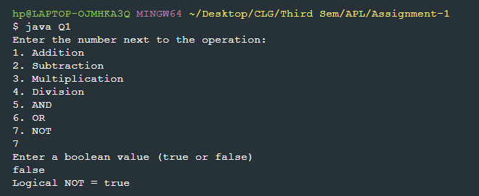

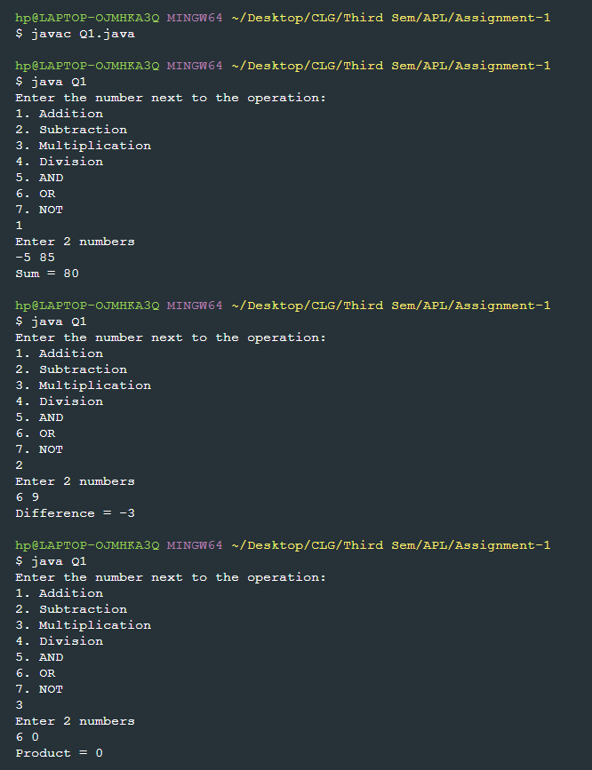

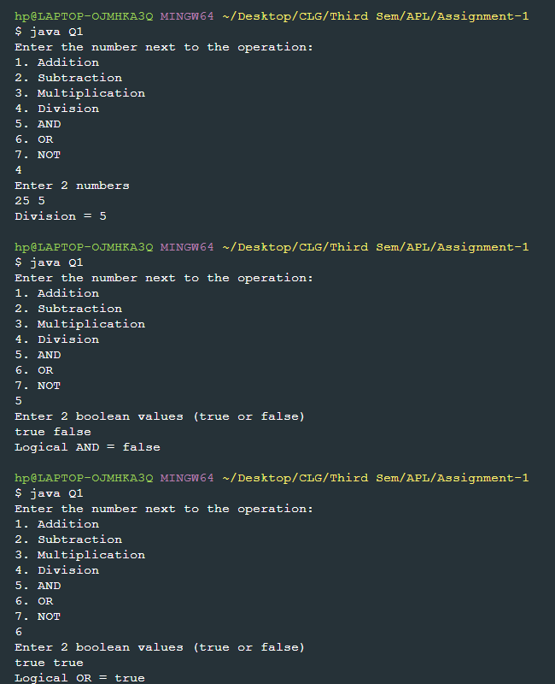

Q2) Write three parameterized constructors for adding two operands, three operands and four operands, respectively in the Addition class and called them with from a main class with three objects.

Code: Q2.java

import java.util.Scanner;  
  
class Addition{  
 int a = 0 , b = 0 , c = 0, d = 0;  
 Addition(int input1 , int input2){  
 a = input1; b = input2;  
 System.out.println(a+b);  
 }  
 Addition(int input1 , int input2, int input3){  
 a = input1; b = input2; c = input3;  
 System.out.println(a+b+c);  
 }  
 Addition(int input1 , int input2, int input3, int input4){  
 a = input1; b = input2; c = input3; d = input4;  
 System.out.println(a+b+c+d);  
 }  
  
}  
  
public class Q2{  
 public static void main(String arg[]){  
 Addition a1 = new Addition(3,4);  
 Addition a2 = new Addition(3,4,5);  
 Addition a3 = new Addition(3,4,5,6);  
 }  
}

Output:

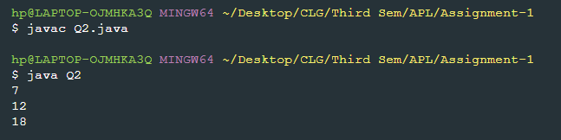

Q3) Write a Java program to find the volume of three different types of Boxes while taking height, width, and depth as inputs. Write two separate programs using the help of methods and parameterized constructors. Similarly, write the Java programs to find the area of a circle and rectangle.

1. Volume of Box by Constructor

Code: Q3_BoxByConstructor.java

import java.util.Scanner;  
  
class Box{  
 float height;  
 float width;  
 float depth;  
 Box(float h , float w , float d){  
 height = h;  
 width = w;  
 depth = d;  
 System.out.println("Volume of box = " + (height*width*depth));  
 }  
}  
  
public class Q3_BoxByConstructor{  
 public static void main(String arg[]){  
 Scanner sc = new Scanner(System.in);  
 System.out.print("Enter height: ");  
 float a = sc.nextFloat();  
 System.out.print("Enter width: ");  
 float b = sc.nextFloat();  
 System.out.print("Enter depth: ");  
 float c = sc.nextFloat();  
  
 Box b2 = new Box(a,b,c);  
  
 }  
}

Output:

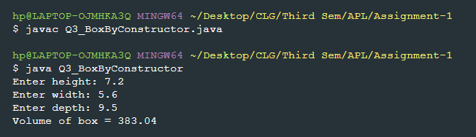

1. Volume of Box by Method

Code: Q3_BoxByMethod.java

import java.util.Scanner;  
  
class Box{  
 float height;  
 float width;  
 float depth;  
  
 public void getData(float a,float b , float c){  
 height = a;  
 width = b;  
 depth = c;  
 }  
 public void calculateVolume(){  
 System.out.println("Volume of box = " + (height*width*depth));  
 }  
}  
  
public class Q3_BoxByMethod {  
 public static void main(String arg[]){  
 Scanner sc = new Scanner(System.in);  
 Box b1 = new Box();  
  
 System.out.print("Enter height: ");  
 float h = sc.nextFloat();  
 System.out.print("Enter width: ");  
 float w = sc.nextFloat();  
 System.out.print("Enter depth: ");  
 float d = sc.nextFloat();  
  
 b1.getData(h,w,d);  
 b1.calculateVolume();  
 }  
}

Output:

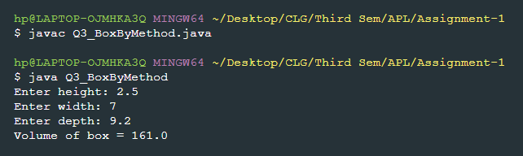

1. Area of Circle by Constructor

Code: Q3_CircleByConstructor.java

import java.util.Scanner;  
  
class Circle{  
 float radius;  
 Circle(float a){  
 radius = a;  
 System.out.println("Area of Circle = " + (3.14f * radius * radius));  
 }  
}  
  
public class Q3_CircleByConstructor{  
 public static void main(String arg[]){  
 Scanner sc = new Scanner(System.in);  
 System.out.print("Enter radius: ");  
 float r = sc.nextFloat();  
  
 Circle c2 = new Circle(r);  
  
 }  
}

Output:

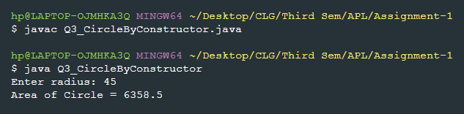

1. Area of Circle By Method

Code: Q3_CircleByMethod.java

import java.util.Scanner;  
  
class Circle{  
 float radius;  
  
 public void getRadius(float a){  
 radius = a;  
 }  
 public void calculateArea(){  
 System.out.println("Area of circle = " + (3.14f * radius * radius));  
 }  
}  
  
public class Q3_CircleByMethod {  
 public static void main(String arg[]){  
 Scanner sc = new Scanner(System.in);  
 Circle c1 = new Circle();  
  
 System.out.print("Enter radius: ");  
 float r = sc.nextFloat();  
  
 c1.getRadius(r);  
 c1.calculateArea();  
 }  
}

Output:

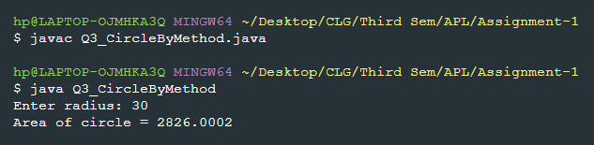

1. Area of Rectangle by Constructor

Code: Q3_RectangleByConstructor.java

import java.util.Scanner;  
  
class Rectangle{  
 float length;  
 float breadth;  
 Rectangle(float a , float b){  
 length = a;  
 breadth = b;  
 System.out.println("Area of Rectangle = " + (length * breadth));  
 }  
}  
  
public class Q3_RectangleByConstructor{  
 public static void main(String arg[]){  
 Scanner sc = new Scanner(System.in);  
  
 System.out.print("Enter length: ");  
 float a = sc.nextFloat();  
 System.out.print("Enter breadth: ");  
 float b = sc.nextFloat();  
  
 Rectangle b2 = new Rectangle(a,b);  
  
 }  
}

Output:

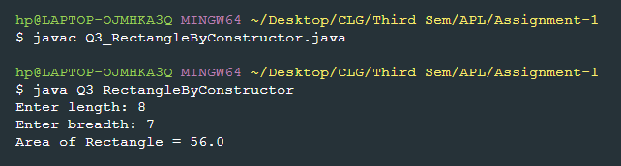

1. Area of Rectangle by Method

Code: Q3_RectangleByMethod.java

import java.util.Scanner;  
  
class Rectangle{  
 float length;  
 float breadth;  
  
 public void getData(float a,float b){  
 length = a;  
 breadth = b;  
 }  
 public void calculateArea(){  
 System.out.println("Area of Rectangle = " + (length * breadth));  
 }  
}  
  
public class Q3_RectangleByMethod {  
 public static void main(String arg[]){  
 Scanner sc = new Scanner(System.in);  
 Rectangle r1 = new Rectangle();  
  
 System.out.print("Enter length: ");  
 float l = sc.nextFloat();  
 System.out.print("Enter breadth: ");  
 float b = sc.nextFloat();  
  
 r1.getData(l,b);  
 r1.calculateArea();  
 }  
}

Output:

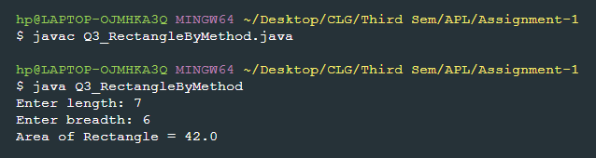

Q4) Write a single program to find the value of the following operations:  
10 & 50, 30 | 40, ~50, 60>>3, 70<<8, 55>>>2.

Code: Q4.java

public class Q4{  
 public static void main(String arg[]){  
 System.out.println("10 & 50 = " + (10&50));  
 System.out.println("30 | 50 = " + (30|50));  
 System.out.println("~50 = " + (~50));  
 System.out.println("60 >> 3 = " + (60>>3));  
 System.out.println("70 << 8 = " + (70<<8));  
 System.out.println("55 >>> 2 = " + (55>>>2));  
 }  
}

Output:

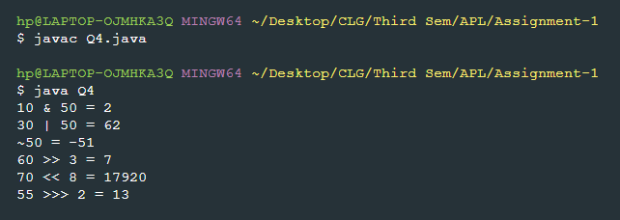

Q5) Write the Java programs to find the maximum and minimum number among four numbers using if-else statement and Ternary operator separately.

1. If-Else

Code: Q5_ByIfElse.java

import java.util.Scanner;  
public class Q5_ByIfElse{  
 public static void main(String arg[]){  
 Scanner sc = new Scanner(System.in);  
 System.out.print("Enter 4 numbers: ");  
 int a = sc.nextInt();  
 int b = sc.nextInt();  
 int c = sc.nextInt();  
 int d = sc.nextInt();  
 int max = a , min = a;  
 if(b>max){  
 max=b;  
 }  
 else if(b<min){  
 min=b;  
 }  
 if(c>max){  
 max=c;  
 }  
 else if(c<min){  
 min=c;  
 }  
 if(d>max){  
 max=d;  
 }else if(d<min){  
 min=d;  
 }  
 System.out.println("Maximum = " + max);  
 System.out.println("Minimum = " + min);  
 }  
}

Output:

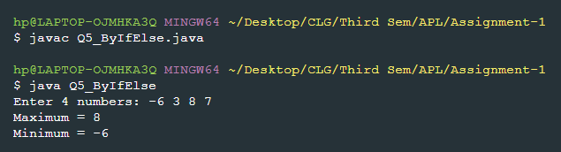

1. Ternary Operator

Code: Q5_ByTernary.java

import java.util.Scanner;  
public class Q5_ByTernary{  
 public static void main(String args[]){  
 Scanner sc = new Scanner(System.in);  
 System.out.print("Enter 4 numbers: ");  
 int a = sc.nextInt();  
 int b = sc.nextInt();  
 int c = sc.nextInt();  
 int d = sc.nextInt();  
 int max = (a > b && a > c && a > d) ? a: ((b > c && b > d) ? b : (c > d ? c : d));  
 int min = (a < b && a < c && a < d) ? a: ((b < c && b < d) ? b : (c < d ? c : d));  
 System.out.println("Maximum = " + max);  
 System.out.println("Minimum = " + min);  
 }  
}

Output:

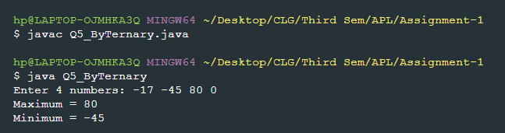

Q6) Write a Java program to find the value of following variables:  
  
z=8,  
a= z++ + ++z,  
b= z-- + --z  
c= z++,  
d=++z,  
e=z--,  
f=--z

Code: Q6.java

public class Q6{  
 public static void main(String arg[]){  
 int z = 8;  
 int a = z++ + ++z;  
 int b = z-- + --z;  
 int c = z++;  
 int d = ++z;  
 int e = z--;  
 int f = --z;  
 System.out.println("Value of z before operations = " + z);  
 System.out.println("a = " + a);  
 System.out.println("b = " + b);  
 System.out.println("c = " + c);  
 System.out.println("d = " + d);  
 System.out.println("e = " + e);  
 System.out.println("f = " + f);  
 System.out.println("Value of z after operations = " + z);  
 }  
}

Output:

